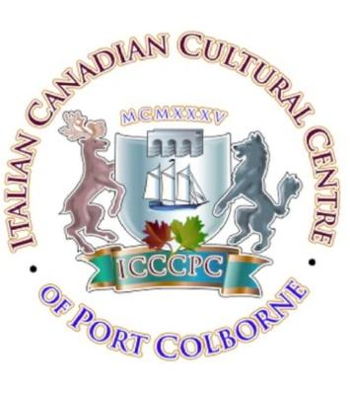
ITALIAN CANADIAN CULTURAL CENTRE
90TH ANNIVERSARY DINNER CELEBRATION
“YOU ARE CORDIALLY INVITED AS OUR SPECIAL GUEST”

Established June 16^{th,} 1935, The Italian Canadian Cultural Centre of Port Colborne was known as The Italian Mutual Benefit Society of Port Colborne and Humberstone.
The Hall has come a long way from conducting meetings in the basements of members homes to our present Hall location on 223 Bell St., Port Colborne, Ontario.
Now, in 2025, we are celebrating our 90th Anniversary. We are excited to commemorate this special occasion.
We would be honored to have you attend. Formal Attire please.
Saturday June 21st, 2025
Doors Open at 6:00 PM
Dinner at 7:00 PM
RSVP: 905-834-3469
or email: Zing67@cogeco.ca

Respectfully,
Mr. Lou Pambianco

President of ICCC

